Project Design Document

1. Design Intent
The goal is to create an experience where users can visually and instantly observe their body’s hidden stress responses in real time. Instead of abstract data, It turns physiological signals into a live, interactive waveform and stress score, making internal reactions visible and tangible. The experience is meant to feel engaging, slightly suspenseful, and insightful—like watching your own body “react” under pressure.
It is designed for:
- Students and researchers interested in human physiology and psychology
- Tech enthusiasts and developers exploring wearable biosensing systems
- General users curious about how their body responds to stress, questioning, or high-pressure situations
It addresses the lack of accessible, real-time insight into physiological stress responses. While traditional polygraph systems are expensive, complex, and not widely available, FLUX provides a low-cost, portable alternative that allows users to explore how stress manifests in the body.
Rather than definitively detecting lies, it helps highlight moments of heightened physiological response, making it useful for understanding stress, emotional reactions, and human behaviour under questioning.

2. Inspiration & References

1. Traditional Polygraph (Lie Detector)
- Measures physiological signals such as heart rate, breathing, blood pressure, and skin conductivity while a person answers questions
- Used in law enforcement, security screening, and investigations
- Relies on the idea that stress responses increase during deception

2. Wearable Stress Trackers (Smartwatches / Fitness Bands)
- Devices like Fitbit, Apple Watch, etc. track:
  - Heart rate
  - Stress levels
  - Activity and sleep
- Focus on health and wellness, not deception or questioning

3. Newer Lie Detection Systems (e.g., Eye Tracking / AI-based)
- Systems like EyeDetect analyze:
  - Eye movement
  - Pupil dilation
  - Reaction time
- Attempt to improve speed and reduce human bias
- Still debated in terms of reliability and accuracy

What Did You Learn From Them?
- Lie detection is indirect
→ Polygraphs don’t detect lies directly—they measure stress responses and interpret them
- Physiological signals are key
→ Heart rate and skin conductivity are consistently used across systems
- No system is perfect
→ Even advanced systems are not fully accurate and remain debated
- Wearables are powerful but underused for this purpose
→ Most wearable tech tracks stress, but does not apply it to real-time questioning or behavioral analysis
- User experience matters
→ Traditional systems are bulky and intimidating, while your design aims to be:
  - portable
  - simple
  - interactive

Images / Links (you can include in report)
- 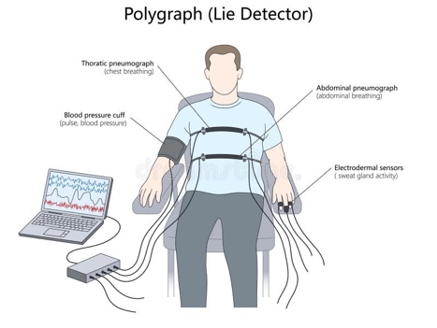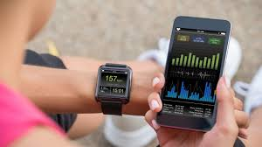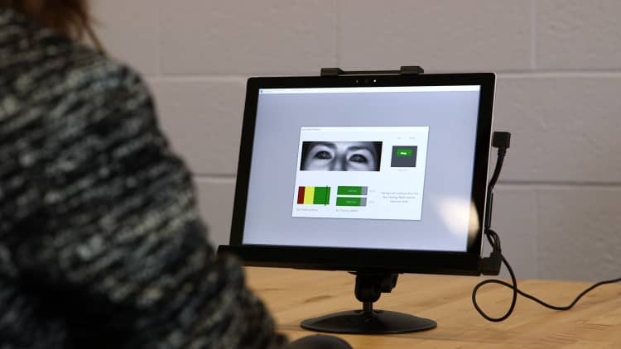
  - https://imotions.com/blog/learning/research-fundamentals/gsr/
  - https://illumin.usc.edu/lie-detection-the-science-and-development-of-the-polygraph/
  - https://antipolygraph.org/yabbfiles/Attachments/GSRANL.pdf

3. User Journey
- User starts
The user wears the device by securing the Velcro band around their hand and placing their finger on the MAX30102 sensor. The device powers on and begins calibration.
- User interacts
The system calibrates a personal baseline over a short period. Once ready, the user asks or is asked a question. During this moment, the device continuously tracks physiological signals such as heart rate and skin conductivity.
- System responds
The OLED display shows a live waveform of the user’s physiological response, along with real-time values. A stress score is calculated and updated, and a classification (calm, elevated, high) is displayed. Simultaneously, the data is sent to the mobile app via Bluetooth, where it is logged and visualized.
Overall, the experience is designed to feel interactive and revealing, allowing users to “see” their internal reactions as they happen.

4. Success Criteria

Functional
- System successfully reads sensor data in real time
- OLED display updates continuously with waveform and values
- Bluetooth data is transmitted to the app without interruption
- Response time is near real-time (within ~1 second)

User Experience
- Device is easy to wear and adjust using the Velcro band
- Setup is simple and intuitive (minimal steps required)
- Display is clear and easy to understand
- Interaction feels engaging and informative

Reliability
- Sensor readings remain stable with proper finger placement
- System runs continuously without crashing
- Data transmission is consistent and accurate

5. System Overview
A wearable system that captures physiological signals, processes them in real time, and translates them into visible and interpretable outputs.
The ESP32 acts as the central controller, reading data from sensors, analyzing stress patterns, and managing both the display and Bluetooth communication

Main Parts of the System
- ESP32 Microcontroller
Processes all sensor data, runs the stress analysis algorithm, and handles communication
- MAX30102 Sensor
Measures heart rate and pulse-related signals
- GSR Sensor
Measures skin conductivity, indicating stress and emotional arousal
- SH1106 OLED Display
Shows live waveform, values, prompts, and results
- Bluetooth (BLE)
Sends real-time data to a mobile app for logging and visualization
- Mobile App (MIT App Inventor)
Displays live data, logs readings, and provides a secondary interface

6. High-Level Block Diagram
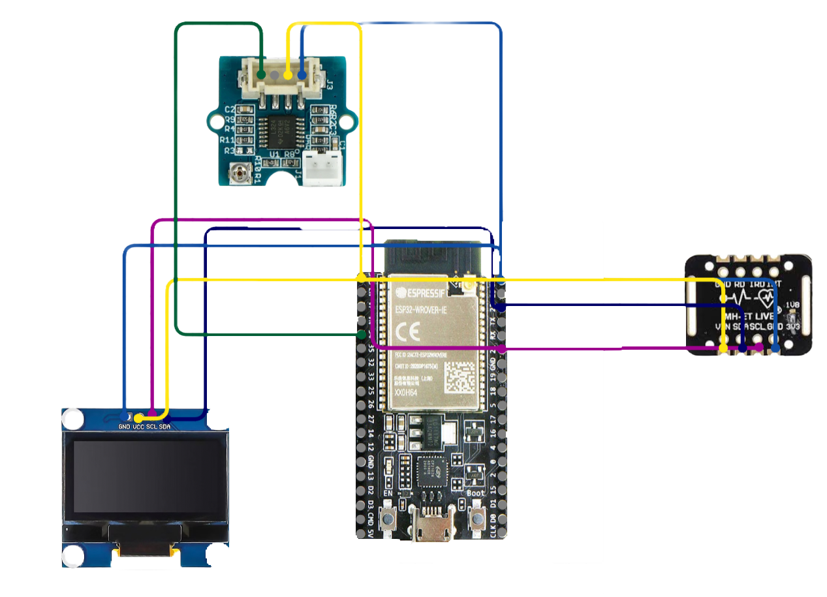

7. Input / Output Mapping
Input | Process | Output
Finger placed on MAX30102 sensor | IR signal captured and filtered | Heart rate (BPM)
Skin contact with GSR sensor | Analog signal read and converted | GSR value (skin conductivity)
Continuous sensor data | Signal smoothing and peak detection | Pulse amplitude, HRV
Baseline calibration data | Average calculation over time | Personal baseline values
Real-time BPM + GSR + amplitude | Comparison with baseline | Stress percentage changes
Stress-related changes | Scoring algorithm applied | Stress score (0–100)
Stress score | Classification logic | State (Calm / Elevated / High)
User triggers question (via app or input) | System enters response window and tracks peak changes | Response analysis
Peak physiological changes during response | Analysis vs pre-question baseline | Verdict (True / Uncertain / Lie-like)
Processed data | Formatting into BLE message | Data packet (e.g., BPM:78 | GSR:1400 ...)
Processed data + state | Display rendering | OLED shows values + live graph + prompts
BLE data packets | Wireless transmission | Mobile app displays live data and logs

8. Sketches & Concepts
